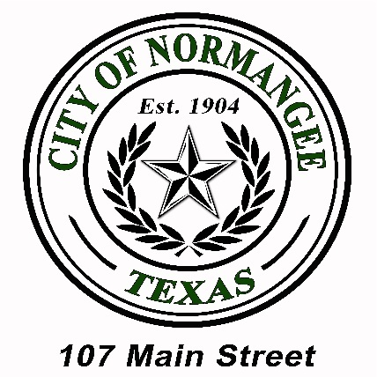
City of Normangee
P.O. Box 37 • Normangee, TX • 77871
Phone: (936) 396-3691 • Fax: (936) 396-5100

Normangee City Council Regular Meeting Agenda
Thursday, April 18, 2024
107 Main Street, Normangee Texas

6:30 PM

- CALL TO ORDER AND ROLL CALL

Mayor and City Council Members
Mayor Troy Noey Mayor Pro Tem Jim Seelye
Council Member Mario Cornish Council Member Glynda Williams
Council Member Dennis Noey Council Member Shannon Wells

City Staff/Appointed Officials
City Secretary Sunny Wobig W/S Operator Janet Boone
Chief of Police Lawrence Bush PW Director Steve Batson
MC Judge Delphia Woodall

- PLEDGE OF ALLEGIANCE
- Pledge of Allegiance
- Prayer

- PRESENTATIONS BY CITIZENS
Introduction of all present. Floor open to discussion on any subject. No action may be taken by law. Citizens wishing to speak may do so after being recognized by the Mayor.

- BUSINESS
Consideration, Discussion and Possible Decision on:
- Previous City Council Meeting Minutes.

- Presentation of TDA Form A1024 CDBG Section 3 Goals and Concepts as related to the CDBG Program and Grant Contract CDV21-0328 (WWTP Grant).

- ARPA AMR Project:
  - Core & Main Contract.
  - Change Order C/O with 3/4’’ curb stop repairs estimated for up to 120 repairs.
  - TX Prevailing Wage Rates for the project.
  - ARPA Terms & Conditions, and Forms.

- Ordinances:
  - Discharge of Firearms Within City Limits.
  - Fireworks Within City Limits.

- Water/Sewer Business:
  - Monthly Update from Public Works Department.

- Municipal Court Business:
  - Monthly Update from Municipal Court.

- Police Department Business:
  - Monthly Update from Police Department.
  - Raises for PD Officers.
  - Electronic Ticket Writers and PD/Court Software Upgrades.

ANNOUNCEMENTS
- NEXT REGULAR MEETING
- May 16, 2024

- EXECUTIVE SESSION
The City Council for the City of Normangee has the right to adjourn into executive session at any time during the course of this meeting to discuss any matter as authorized by Government Code Sections 551.071 (Consultation with Attorney), 551.072 (Deliberations about Real Property), 551.073 (Deliberations about Gifts and Donations), 551.074 (Personnel Matters), 551.076 (Deliberations about Security Devices), and 551.086 (Economic Development).

- ADJOURN

Notice is posted in accordance with Chapter 551, Government Code, Vernon’s Texas Codes, Annotated. I certify that the above notice of meeting was posted at Normangee City Hall on the
15th day of April, 2024 at 5:30 PM, and that the date and time of the meeting have been posted on www.cityofnormangee.org.

______________________________________________
Approved and Posted by Sunny Wobig, City Secretary

All Agenda items listed above are eligible for discussion and actions unless otherwise specifically noted.
This facility is wheelchair accessible. Accessible parking spaces are available.
Requests for auxiliary aids and services must be made 48 hours prior to this meeting
by calling (936) 396-3691.

NOTICE: Pursuant to Section 30.06, Penal Code (trespass by license holder with a concealed handgun), a person licensed under Subchapter H, Chapter 411, Government Code (handgun licensing law), may not enter this property with a concealed handgun.
NOTICE: Pursuant to Section 30.07, Penal Code (trespass by license holder with an openly carried handgun), a person licensed under Subchapter H, Chapter 411, Government Code (handgun licensing law), may not enter this property with a handgun that is carried openly.

