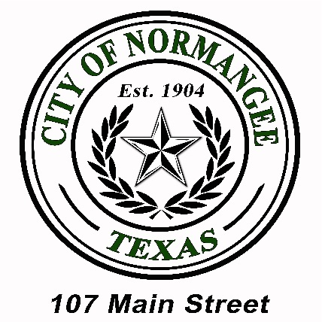
P.O. Box 37 • Normangee, TX • 77871
Phone: (936) 396-3691 • Fax: (936) 396-5100

Normangee City Council Regular Meeting Agenda
Thursday, June 24, 2021
5:00 PM

- CALL TO ORDER AND ROLL CALL

Mayor and City Council Members
Mayor Troy Noey
Mayor Pro-Tem Melanie Minter Council Member Mario Cornish
Council Member Dennis Noey Council Member Brian Horn

City Staff/Appointed Officials
City Secretary Sunny Wobig
Chief of Police J.D. Cornelius
PW Director Steve Batson

- PLEDGE OF ALLEGIANCE
- Pledge of Allegiance
- Prayer

- PRESENTATIONS BY CITIZENS
Introduction of all present. Floor open to discussion on any subject. No action may be taken by law. Citizens wishing to speak may do so after being recognized by the Mayor.

- BUSINESS
Consideration, Discussion and Possible Decision on:
- Approve Previous City Council Meeting Minutes.
- Cedar Way – Undeveloped City Street Behind Fire House.
- Installation of Speed Bumps.
- Employee Benefit Coverage Renewal.
- Water/Sewer Business:
  - Monthly Update from Steve Batson and Janet Boone.
- Police Department Business:
  - Monthly Update from Chief Cornelius.

ANNOUNCEMENTS
- NEXT REGULAR MEETING
- EXECUTIVE SESSION
The City Council for the City of Normangee has the right to adjourn into executive session at any time during the course of this meeting to discuss any matter as authorized by Government Code Sections 551.071 (Consultation with Attorney), 551.072 (Deliberations about Real Property), 551.073 (Deliberations about Gifts and Donations), 551.074 (Personnel Matters), 551.076 (Deliberations about Security Devices), and 551.086 (Economic Development).

- ADJOURN
Notice is posted in accordance with Chapter 551, Government Code, Vernon’s Texas Codes, Annotated. I certify that the above notice of meeting was posted on the bulletin board at Normangee City Hall and the front glass door of Normangee City Hall on the 21st day of June, 2021 at 3:00 PM.

______________________________________________
Approved and Posted by Sunny Wobig, City Secretary

All Agenda items listed above are eligible for discussion and actions unless otherwise specifically noted.
This facility is wheelchair accessible. Accessible parking spaces are available.
Requests for auxiliary aids and services must be made 48 hours prior to this meeting
by calling (936) 396-3691.

NOTICE: Pursuant to Section 30.06, Penal Code (trespass by license holder with a concealed handgun), a person licensed under Subchapter H, Chapter 411, Government Code (handgun licensing law), may not enter this property with a concealed handgun.
NOTICE: Pursuant to Section 30.07, Penal Code (trespass by license holder with an openly carried handgun), a person licensed under Subchapter H, Chapter 411, Government Code (handgun licensing law), may not enter this property with a handgun that is carried openly.

